 

INSTITUTE FOR ADVANCED COMPUTING AND SOFTWARE DEVELOPMENT AKURDI, PUNE

Documentation On

**“Online Food Order System”**

PG-DAC SEPT 2021

*Submitted By:*

**Group No: 59**

**Krutika Rangari 219091**

**Nidhi Pakhan 219112**

**Prashant Karhale Mr. Kashinath Patil**

**Centre Coordinator Project Guide**

# Table of Contents

1. Introduction 4

Problem Statement 5

Product Scope 5

Aim & Objectives 5

1. Overall Description 7

Proposed System 7

Benefits of Society Management System 8

User and Characteristics 8

Operating Environment 11

1. Requirements Specification 11

External Interface Requirements 12

1. System Diagram 13

Activity Diagram 13

Data Flow Diagram 15

Class Diagram 19

Use Case Diagram 20

ER Diagram 21

1. Table Structure 22

Addresses 22

users 22

cart 22

order_details 23

order 23

payment 23

products 24

1. Conclusion 25

Future Scope 25

1. References 26

**List of Figures**

Figure 1 Customer Activity Diagram 11

Figure 2 Admin Activity Diagram 12

Figure 3 Restaurant Employee Activity Diagram 12

Figure 4 Data Flow Diagram 13

Figure 5 Data Flow Diagram for Admin 14

Figure 6 Data Flow Diagram for Customer 14

Figure 7 Data Flow Diagram for Restaurant Employee 15

Figure 8 Class Diagram 15

Figure 9 Use Case Diagram 16

Figure 10 ER Diagram 16

# Introduction

It is known globally that, in today’s market, it is extremely difficult to start a new small-scale business and live-through the competition from the well-established and settled owners. In fast paced time of today, when everyone is squeezed for time, the majority of people are finicky when it comes to placing a food order. The customers of today are not only attracted because placing an order online is very convenient but also because they have visibility into the items offered, price and extremely simplified navigation for the order.

Online ordering system that we are proposing here, greatly simplifies the ordering process for both the customer and the restaurant. System presents an interactive and up-to-date menu with all available options in an easy to use manner. Customer can choose one or more items to place an order which will land in the Cart. Customer can view all the order details in the cart before checking out. At the end, customer gets order confirmation details. Once the order is placed it is entered in the database and retrieved in pretty much real time. This allows Restaurant Employees to quickly go through the orders as they are received and process all orders efficiently and effectively with minimal delays and confusion.

## Problem Statement

Our proposed system is an online food ordering system that enables ease for the customers. It overcomes the disadvantages of the traditional queueing system. Our proposed system is a medium to order online food hassle free from a restaurant. This system improves the method of taking the order from customer. The online food ordering system sets up a food menu online and customers can easily place the order as per their wish. The payment can be made online or pay-on-delivery system. For more secured ordering separate accounts are maintained for each user by providing them an ID and a password.

## Product Scope

For placing any orders customers have to visit hotels or restaurants to know about food items and then place order and pay. In this method time and manual work is required.

While placing an order over the phone, customer lacks the physical copy of the menu item, lack of visual confirmation that the order was placed correctly. Every restaurant needs certain employees to take the order over phone or in-person, to offer a rich dining experience and process the payment. In today’s market, labor rates are increasing day by day making it difficult to find employees when needed.

Hence, to solve this issue, what we propose is an “Online Food Order System”. The main advantage of our system is that it greatly simplifies the ordering process for both the customer and the restaurant and also greatly lightens the load on the restaurant’s end, as the entire process of taking orders is automated.

## Aims & Objectives

* To develop a system that will surely satisfy the customer.
* To design a system able to accommodate huge amount of orders at a time.
* To improve the communication between the customer and the restaurant and minimize the time of ordering.
* One of the main objectives of a restaurant to ensure customer satisfaction. Manual listing of order by the waiters/waitresses may result to slow response in customer service. Hence, if the restaurant uses the proposed system, manipulation of orders will be easy and quick by choosing the desired menu.
* To automatically compute the bill. The system will also automatically calculate and displays the final bill without having any error because the information for that item is already inserted.

# Overall Description

**PROPOSED SYSTEM**

* This system has a bunch of benefits from various point of views. This online application enables the end-users to register to the system online, select the food items of their choice from the menu list, and order food online. Also, the payment can be made at the time of home delivery depending upon the customer’s choice and convenience.
* The selection made by the customers will be available to the hotel reception or to the person handling the work assignment. Now this same person will assign the orders to the chef . As soon as the chef prepares the food, the later person forwards the parcels to the delivery persons assigned with the location and customer identity of the customer along with the bill status. After the delivery of the food the delivery person will update the delivery status to delivered.
* With this application, the workload of the waiter in the restaurant is reduced. One of the various benefits of this is system is that if there is a rush or a huge crowd present in the restaurant then in that case sometimes unavailability of tables cut downs the restaurant’s customer.
* Also, there will be chances that the waiters are unavailable as they are busy handling others, so the customer can directly order the food online by using this application. This system allows the staff to serve customers within less time as compared to the manual system.

## Benefits of Online Food Order System

* Makes the ordering process easier:

Traditionally, people had to make calls to place orders or drive to the restaurants for a take-out, then wait for the food to be prepared and delivered. The best solution is switching over to online ordering. Restaurants owners can create a website or an app or both that will not only make the ordering process easier for customers but also streamline restaurant operations. Having an online ordering system can make day-to-day operations more efficient for a restaurant. On the other hand, when a customer places an order online, They take their time to browse the menu

* Efficient customer and order management:

An online ordering system for Restaurants helps enhance the customer-restaurant relationship by providing end to end Customer Relationship Management system. It provides a complete sales dashboard with information about orders. It also comes with an order management system that streamlines the entire ordering process .

* Stay ahead of the competition:

This is the opportunity to make your restaurants available to your customers on their fingertips. With the growing consumer demand for faster, more convenient ways to order, independent restaurants are investing in this new takeout technology to stay ahead in the competition

* Greater reach:

The restaurant seating capacity maybe 100-200 at a time, or even less, but with online ordering, you can reach thousands of people at a time, and cater to a much larger number without having to make any additional investment in staff or infrastructure. All you need is a well-integrated online ordering system and you are good to go!

## Users and Characteristics:

Admin:

* Add, Modify and Delete Category: Allows to add or update and delete food Category name .
* Add, Modify and Delete Product: Allows to add or update and delete Product Name, Description, Price and choose particular Category .
* Manages Restaurant Employee and Delivery Boy : Provides User Id and Password.

Customer:

Customers of the Web Ordering system will interact with the application through an easy to use top navigation menu.

* “Home” menu option: allows the users to select an item to place an order.
* “Menu” option: Allows users to see all food items per category.
* “My Cart (x)”menu option:
* Allows users to see details of the items placed in cart. Details include Category, Product Name, Product Description, Price. It also allows to Remove item from cart . User can then use a submit order button to proceed further.
* Once, Submit Order button is selected, user will be prompted to add address method . If the address already exist user can select ‘use existing address’ button .
* Once, button is selected, user will be prompted for the payment method . Cash on delivery or Card payment.
* User will then be presented with a “My Order” page, which will display order details to review. User can then use a ‘Place Order’ button to place an order.
* Once order is placed, user will be presented with appropriate Order confirmation success/failure message.

Restaurant Employee :

* Manages Delivery Boy: Allows to add or update and delete Delivery Boy profile. Also provides Id and password to the Delivery Boy.
* Update Delivery status: Allows to change the delivery status from Pending to Delivered after the order is delivered.
* Monitor the Orders : Keeps the track of all the orders.

Delivery Boy :

* Manage Order Delivery status: Allows to change the delivery status from Pending to Delivered after the order is delivered.

## Operating Environment:

Server Side:

**Processor:** AMD Ryzen 5 4600H with Radeon Graphics, 3000 Mhz, 6 Core(s), 12 Logical Processor(s)

**HDD:** Minimum 1TB Disk Space, SSD 256 GB

**RAM:** Minimum 8GB

**OS:** Windows

**Database:** MYSQL

# Specific Requirement

## External Interface Requirements:

User Interfaces:

* + All the users will see the same page when they enter in this website. This page asks the users a username and a password.
  + After being authenticated by correct username and password, user will be redirect to their corresponding profile where they can do various activities.
  + The user interface will be simple and consistence, using terminology commonly understood by intended users of the system. The system will have simple interface, consistence with standard interface, to eliminate need for user training of infrequent users.

Hardware Interfaces:

* + No extra hardware interfaces are needed.
  + The system will use the standard hardware and data communication resources.
  + This includes, but not limited to, general network connection at the server/hosting site, network server and network management tools.

Application Interfaces:

**OS:** Windows 10

**Web Browser:**

The system is a web-based application; clients need a modern web browser such as Mozilla Firebox, Internet Explorer, and Chrome. The computer must have an Internet connection in order to be able to access the system.

Communications Interfaces:

* + This system uses communication resources which includes but not limited to, HTTP protocol for communication with the web browser and web server and TCP/IP network protocol with HTTP protocol.
  + This application will communicate with the database. Users can contact with server side through HTTP protocol. This function allows the application to use the data retrieved by server to fulfil the request fired by the user.

# System Design

## Activity Diagram

**Figure 1: Customer Activity Diagram**

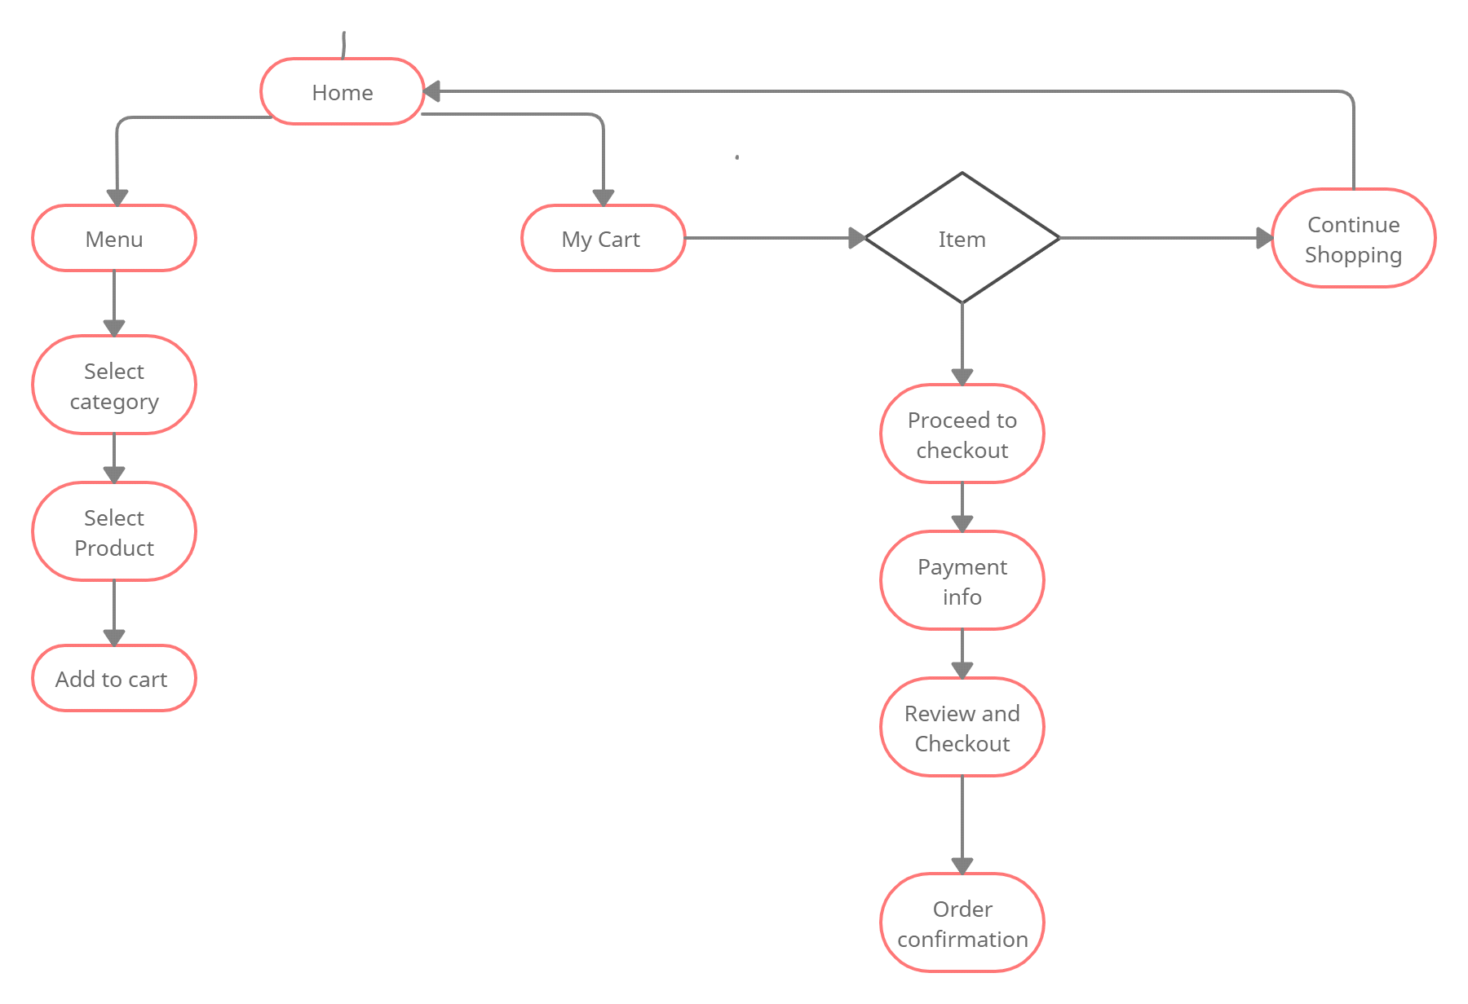

**Figure 2: Admin Activity Diagram**

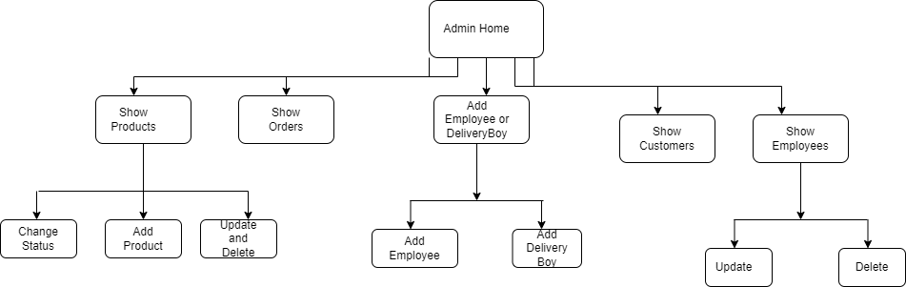

**Figure 3: Restaurant Employee Activity Diagram**

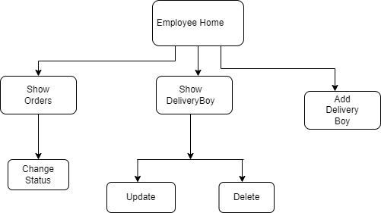

## Data Flow Diagram

**Figure 4: Level 1 Data Flow Diagram**

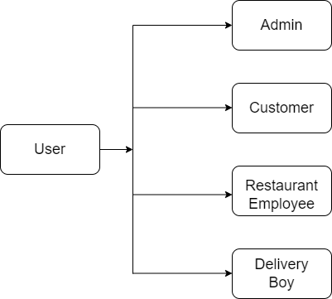

**Figure 5: Data Flow Diagram for Admin**

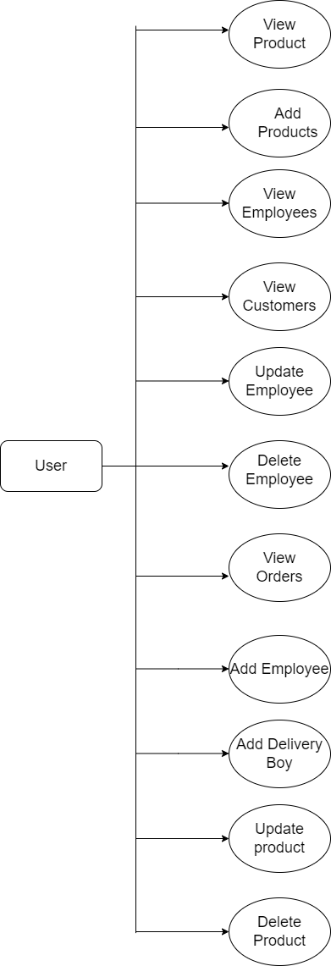

**Figure 6: Data Flow Diagram for customer**

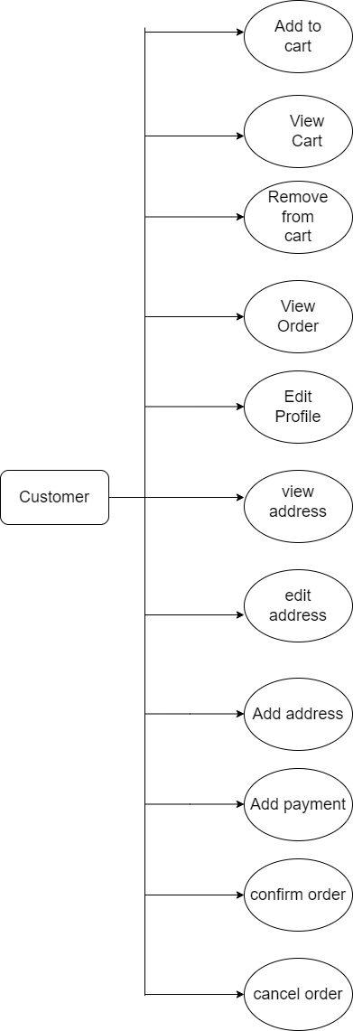

**Figure 7: Data Flow Diagram for Restaurant employee**

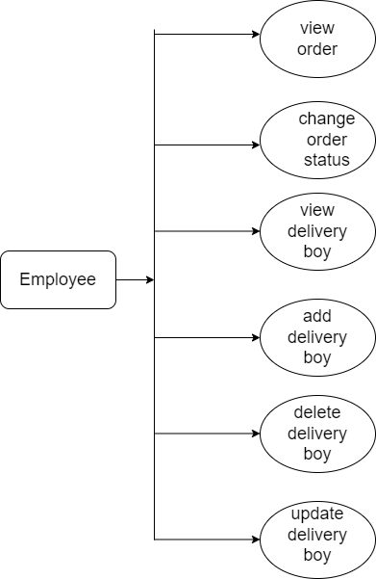

## Class Diagram

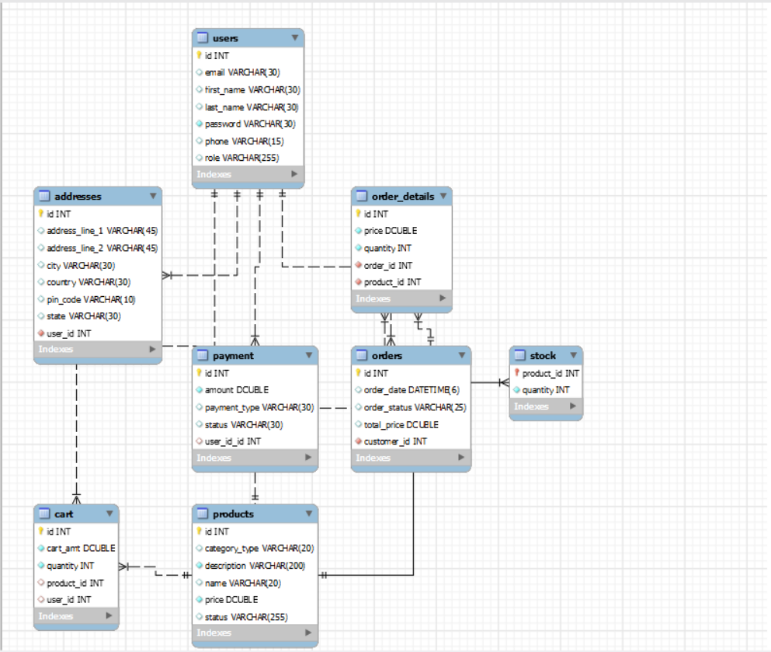

**Figure 8: Class Diagram**

## Use Case Diagram

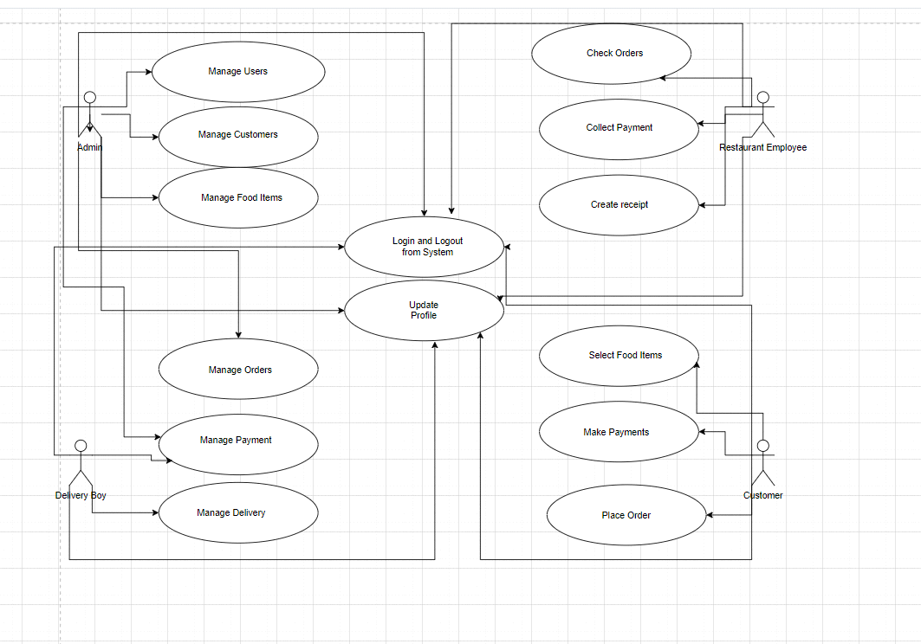

**Figure 9: Use Case Diagram**

## ER Diagram

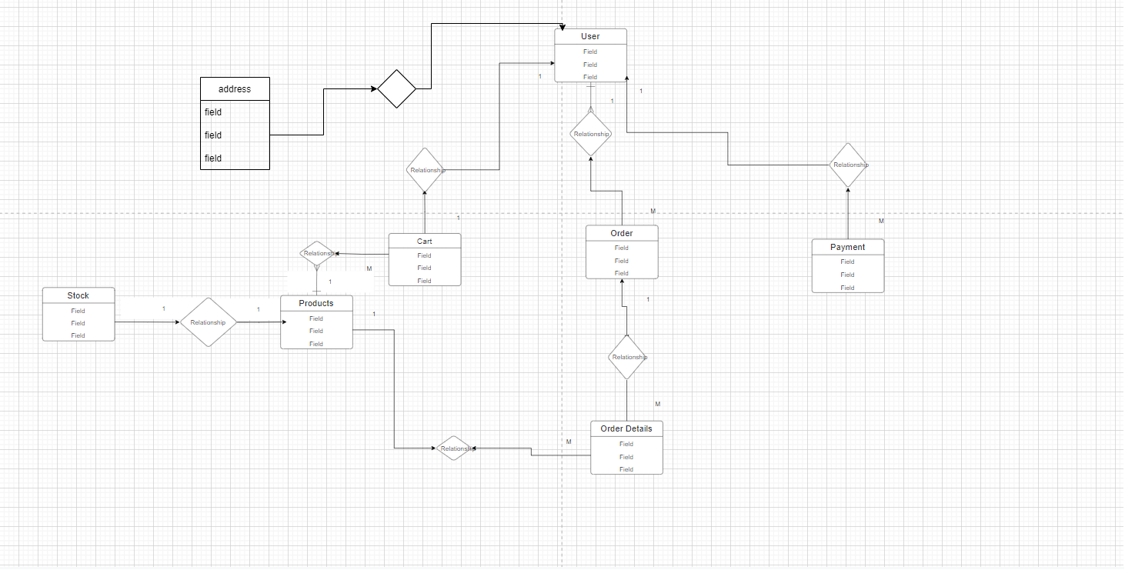

# Table Structure

## Addresses:

|  |  |  |  |  |  |
| --- | --- | --- | --- | --- | --- |
| Field | Type | Null | Key | Default | Extra |
| id | int | NO | PRI | NULL | Auto_increment |
| address_line_1 | varchar(45) | YES |  | NULL |  |
| address_line_2 | varchar(45) | YES |  | NULL |  |
| city | varchar(30) | YES |  | NULL |  |
| country | varchar(30) | YES |  | NULL |  |
| pincode | varchar(10) | YES |  | NULL |  |
| state | varchar(30) | YES |  | NULL |  |
| user_id | int | NO | MUL | NULL |  |

## users:

|  |  |  |  |  |  |
| --- | --- | --- | --- | --- | --- |
| Field | Type | Null | Key | Default | Extra |
| id | int | NO | PRI | NULL | Auto_increment |
| email | varchar(30) | YES | UNI | NULL |  |
| first_name | varchar(30) | YES |  | NULL |  |
| last_name | varchar(30) | YES |  | NULL |  |
| password | varchar(200) | NO |  | NULL |  |
| phone | varchar(10) | YES |  | NULL |  |
| role | varchar(100) | YES |  | NULL |  |

## cart:

|  |  |  |  |  |  |
| --- | --- | --- | --- | --- | --- |
| Field | Type | Null | Key | Default | Extra |
| id | int | NO | PRI | NULL | Auto_increment |
| cart_amt | double | YES |  | NULL |  |
| quantity | int | NO |  | NULL |  |
| product_id | int | NO | MUL | NULL |  |
| user_id | int | NO | MUL | NULL |  |

## order_details:

|  |  |  |  |  |  |
| --- | --- | --- | --- | --- | --- |
| Field | Type | Null | Key | Default | Extra |
| id | int | NO | PRI | NULL | Auto_increment |
| price | double | YES |  | NULL |  |
| quantity | int | YES |  | NULL |  |
| order_id | int | YES | MUL | NULL |  |
| product_id | int | YES | MUL | NULL |  |

## orders:

|  |  |  |  |  |  |
| --- | --- | --- | --- | --- | --- |
| Field | Type | Null | Key | Default | Extra |
| id | int | NO | PRI | NULL | Auto_increment |
| order_date | datetime(6) | YES |  | NULL |  |
| order_status | varchar(25) | YES |  | NULL |  |
| total_price | double | YES |  | NULL |  |
| customer_id | int | YES | MUL | NULL |  |

## payment:

|  |  |  |  |  |  |
| --- | --- | --- | --- | --- | --- |
| Field | Type | Null | Key | Default | Extra |
| id | int | NO | PRI | NULL | Auto_increment |
| amount | double | NO |  | NULL |  |
| payment_type | varchar(30) | YES |  | NULL |  |
| status | varchar(30) | YES |  | NULL |  |
| user_id | int | YES | MUL | NULL |  |

## products:

|  |  |  |  |  |  |
| --- | --- | --- | --- | --- | --- |
| Field | Type | Null | Key | Default | Extra |
| id | int | NO | PRI | NULL | Auto_increment |
| category_type | varchar(30) | YES |  | NULL |  |
| description | varchar(200) | NO |  | NULL |  |
| name | varchar(30) | YES |  | NULL |  |
| price | double | NO |  | NULL |  |
| status | varchar(20) | YES |  | NULL |  |

# Conclusion

An online food ordering system is developed where the customers can make an order for the food and avoid the hassles of waiting for the order to be taken by the waiter. Using the application, the end users register online, read the E-menu card and select the food from the e-menu card to order food online. Once the customer selects the required food item the chef will be able to see the results on the screen and start processing the food. This application nullifies the need of a waiter or reduces the workload of the

waiter.

The advantage is that in a crowded restaurant there will be chances that the waiters are overloaded with orders and they are unable to meet the requirements of the customer in a satisfactory manner. Therefore by using this application, the users can directly place the order for food to the chef online.

In conclusion an online food ordering system is proposed which is useful in small family run restaurants as well as in places like college cafeteria, etc. This project can later be expanded on a larger scale. It is developed for restaurants to simplify their routine managerial and operational task and to improve the dining experience of the clients. This also helps the restaurant owners develop healthy customer relationships by providing reasonably good services. The system also enables the restaurant to know the items available in real time and make changes to their food and beverage inventory based on the orders placed and the orders completed.

# Future Scope

The following section describes the work that will be implemented with future releases of the software.

* Customize orders: Allow customers to customize food orders
* Enhance User Interface by adding more user interactive features. Provide Deals and promotional Offer details to home page. Provide Recipes of the Week/Day to Home Page
* Payment Options: Add different payment options such as PayPal, Cash, Gift Cards etc. Allow to save payment details for future use.
* Delivery Options: Add delivery option
* Order Tracking: Live tracking of the delivery.

# 7.0 References

[1] https://docs.spring.io/spring-data/jpa/docs/current/reference/html/#preface

[2] https://react-bootstrap.github.io/getting-started/introduction/

[3] https://stackoverflow.com/

[4]<https://docs.oracle.com/en/java/javase/11/docs/api/java.base/java/lang/Integer.html>

[5]https://reactjs.org/docs/getting-started.html